BIO – Candy Yoder

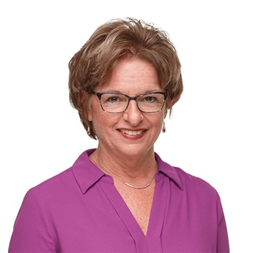
Short Bio
As Chief Program Officer, Candy Yoder oversees all the grant making processes at the Community Foundation of Elkhart County and focuses on helping children and families in the community. She works with the Program Team and grant making committees to give grants and help assure successful outcomes. She joined the foundation in summer 2018 after nearly three decades at Child And Parent Services. She joined CAPS in 1989 as a program coordinator, leading the development of new programs. She became President and CEO in 2009 and oversaw significant growth for the organization. Candy has served on the boards for Concord Community Schools, Horizon Education Alliance and Goshen Health System. She is a member of Sugar Grove Church and Elkhart Rotary Club. She has been married to Darrel for more than 40 years and has two adult children. In her rare spare time, she enjoys bicycling and reading.

Long Bio
As Chief Program Officer, Candy Yoder oversees all the grant making processes at the Community Foundation of Elkhart County and focuses on helping children and families in the community. She will works with the Program Team and grant making committees to give grants and help assure successful outcomes.

She joined the foundation in summer 2018 after nearly three decades at Child And Parent Services. She joined CAPS in 1989 as a program coordinator, leading the development of new programs. In 2009, she became President and CEO when the organization’s founder retired. Under her leadership, CAPS grew to serve more than 6,000 children and families a year with a broad range of programs. In 2017, the organization opened the new Joy Rose Center following strong community support with contributions of $5.7 million to build the new operations center.

Candy earned her bachelor's degree in social work from Eastern Mennonite University and a master’s degree of Public Affairs from Indiana University South Bend. She has served on the boards for Concord Community Schools, Horizon Education Alliance, Goshen Health System and Tolson Center for Community Excellence. In 2014, she was named a YWCA Woman of the Year for the North Central Indiana region.

She is active in Sugar Grove Church and Elkhart Rotary Club. She has been married to Darrel for more 40 years and are parents of two adult children. In her spare time, she enjoys bicycling and reading.

