BIO – Cole Patuzzi

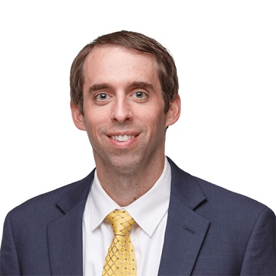
Short Bio
Cole Patuzzi is the Chief Financial Officer for the Community Foundation of Elkhart County. He is part of the team responsible for tracking the foundation’s financial activity. He also helps implement investment decisions and oversee operations, including human relations and IT services. He joined the Community Foundation in 2013 after working as an accountant in the Elkhart office of Kruggel, Lawton and Company LLC from 2009 to 2013. He graduated summa cum laude from Bethel College in Mishawaka, Indiana, in 2008 with bachelor’s degrees in both mathematics and accounting. Cole attends Brenneman Memorial Missionary Church in Goshen and is a member of Goshen Rotary Club. He was a honored in the Michiana Forty Under 40 Class of 2018 for the South Bend-Elkhart Region. In his spare time, he enjoys running and spending time with family and friends.

Long Bio
Cole Patuzzi is the Chief Financial Officer for the Community Foundation of Elkhart County. He is part of the team responsible for tracking the foundation’s financial activity. He also helps implement investment decisions and oversee operations, including human relations and IT services.

He joined the Community Foundation in 2013 as CFO and Controller. Now as the CFO, he oversees the accounting of more than 400 funds with total assets of nearly $300 million. He is responsible for the accounting and financial processes, annual budget and tax filings, as well as implementing the decisions of the foundation’s Investment Committee.

He grew up in the outskirts of Goshen, Indiana. In 2008, he graduated summa cum laude from Bethel College in Mishawaka with a bachelor of arts degree in accounting and bachelor of science in mathematics.

He worked in the Elkhart office of Kruggel, Lawton and Company LLC from 2009 to 2013 and became a certified public accountant in 2011.

Cole attends Brenneman Memorial Missionary Church in Goshen and is a member of Goshen Rotary Club. He was a honored in the Michiana Forty Under 40 Class of 2018 for the South Bend-Elkhart Region.

In his spare time, he enjoys running and spending time with family and friends.

